Dung Beetle Fact Sheet: 1
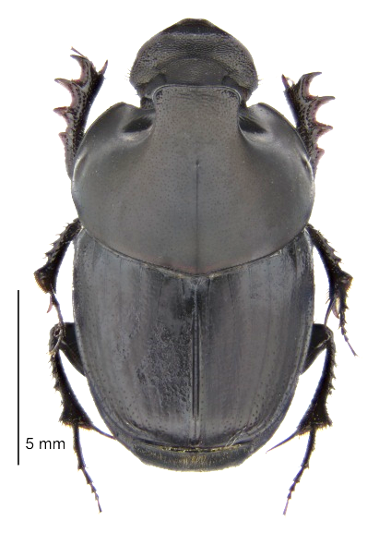
Onthophagus binodis
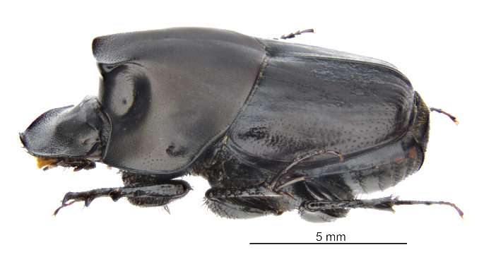

Size: up to 13 mm
Characteristic features: male with ‘hump’ across its shoulders. Female with hump reduced to a ridged line across the shoulders. Both sexes have a matt-black finish to their backs. New adults often have dark brown colour which darkened to black when their shell has hardened.
Origin: Native to Southern Africa.
Export Distribution: Australia, Canada, New Zealand. For use in the burial of pastoral dung and control of dung-breeding pests.
Expected distribution in New Zealand: North Island (preferred) and South Island
Flight Activity: Day time
Seasonal Activity: Active from late spring to autumn. Adults that emerged from the soil in autumn will also overwinter in burrows underground. On mild days some adults will come to the surface to feed and top up their fat reserves for winter. Fattened mature grubs will overwinter in the dung balls they have been developing in underground. If the soil temperature is not too cold, these will continue to develop slowly into new adults which will emerge in Spring.
Dung preferences: Fresh firm to liquid cattle dung, also attracted to fresh sheep, horse, goat and alpaca dung.
Nesting behaviour: Adults build nesting galleries at the end of burrows approximately 20-30 cm below the dung pat. Galleries are packed with several dung masses or brood sausages each with one egg.
Life Cycle: Development from egg-adult takes 8-10 weeks depending on soil temperature. There are at least two generations a year.
Abundance: The number of dung beetles per farm depends on many criteria but most importantly the amount of fresh dung available, and dung quality. In ideal circumstances populations should reach saturation from year 9 onwards post establishment. Chemical residues from livestock drenches can be detrimental but not critical to dung beetle population growth. Dung beetle friendly drenches are available. An integrated approach using dung beetles and drenches is recommended with an awareness of the side effects chemical residues in drenches can have on of dung beetles. For information on dung beetles, drenches and dung beetle management please refer to the Dung Beetle Innovations website: www.dungbeetles.co.nz

